Final Report
CSE303: Database Management System
Section: 2
Group: 2

1621185 - Mehedi Hasan Masuk
1830422 - Tahsin Bin Khaled
1830329 - Jahid Hasan
1830295 - Tonmoy Baishnob
1820555 - jannatul ferdaous
2022053 - Samiul Alim Lesum

Contents :

CHAPTER 1: INTRODUCTION
BACKGROUND OF THE PROJECT
OBJECTIVE OF THE PROJECT
SCOPE OF THE PROJECT

CHAPTER 2: REQUIREMENT ANALYSIS
RICH PICTURE (AS-IS)
SIX ELEMENTS (AS-IS)
PROCESS DIAGRAM (AS-IS)
PROBLEM ANALYSIS
RICH PICTURE (TO-BE)
SIX ELEMENTS (TO-BE)
PROCESS DIAGRAM (TO-BE)

CHAPTER 3: LOGICAL SYSTEM DESIGN
BUSINESS RULE
ENTITY RELATIONSHIP DIAGRAM
ENTITY RELATIONSHIP DIAGRAM TO RELATIONAL SCHEMA
NORMALIZATION
DATA DICTIONARY

CHAPTER 4: PHYSICAL SYSTEM DESIGN
INPUT FORMS
OUTPUT FORMS

CHAPTER 5: CONCLUSION
PROBLEM AND SOLUTION
ADDITIONAL FEATURES AND FUTURE DEVELOPMENT
CONCLUSION AND RECOMMENDATIONS

CHAPTER 1
INTRODUCTION
● BACKGROUND OF THE PROJECT
● OBJECTIVE OF THE PROJECT
● SCOPE OF THE PROJECT

BACKGROUND OF THE ORGANIZATION

IUB is a well-recognized private university in Bangladesh. It is located in Bashundhara Residential Area of Dhaka, Bangladesh. It was established in 1993 under the Private University Act, 1992.[1][2] with an explicit focus on Research and Global partnerships. IUB has an enrollment of 7,378 students, 11,556 alumni and 401 faculty members (of which 38% have PhD's mostly from North America). IUB is the only university in Bangladesh that was shortlisted in the Times Higher Education (THE) Awards 2020 for student recruitment campaign of the year. IUB's position is at the top in the whole of Asia. According to world university rankings of Times Higher Education (THE) IUB stands within 400th universities globally in terms of various aspects of impact analysis.

BACKGROUND OF THE PROJECT

The aim of our project is to build a system that will improve our current system of grading our students, tracking students PLO and Co’s as well as generating reports. The main goal was to improve current PLO and CO tracking system to reduce time in between process of different departments and also to Visualize our system data so that it can be easier to understand our flaws and where we need more improvement. The visualization of data will help higher authorities to take better decision for our institution. Our fellow students will be able to track progress of their university life throughout the system. In addition, our software hopes to benefit the institutional bodies as well as faculty members, administrative bodies and departmental bodies as well throughout the system it’ll be more easy to map PLO’s and CO’s with different courses and faculty member will be able to upload CO’s directly to the system .

OBJECTIVE OF THE PROJECT

Our project intends to create an interactive, user-friendly software that will act as a platform for students, faculties and other members of the university to help improve the quality of education and
revolutionize the way we integrate technology into our education. We believe the data we have
collected, evaluated and arranged will unlock opportunities for massive advancements in our
educational sector and will also contribute significantly to the field of Computer Science. Such being
the case, The system will enhance the project scope so that it will bring about benefits to all of the
Departments.

SCOPE OF THE PROJECT
The scope is to assist in the efficient and effective implementation of the project through the following tasks:
➔ Doing research about the university and its current system
➔ Collecting data of current system
➔ Finding out flaws and scope of improvements
➔ System Designing
➔ Data modeling
➔ System Modeling
➔ Program Analysis
➔ Reporting
➔ Project management
➔Time management

CHAPTER 2
REQUIREMENT ANALYSIS
● RICH PICTURE AS-IS
● SIX ELEMENTS AS IS
● PROCESS DIAGRAM AS-IS
● PROBLEM ANALYSIS
● RICH PICTURE TO-BE
● SIX ELEMENTS TO-BE
● PROCESS DIAGRAM TO BE

Rich Picture – As Is:

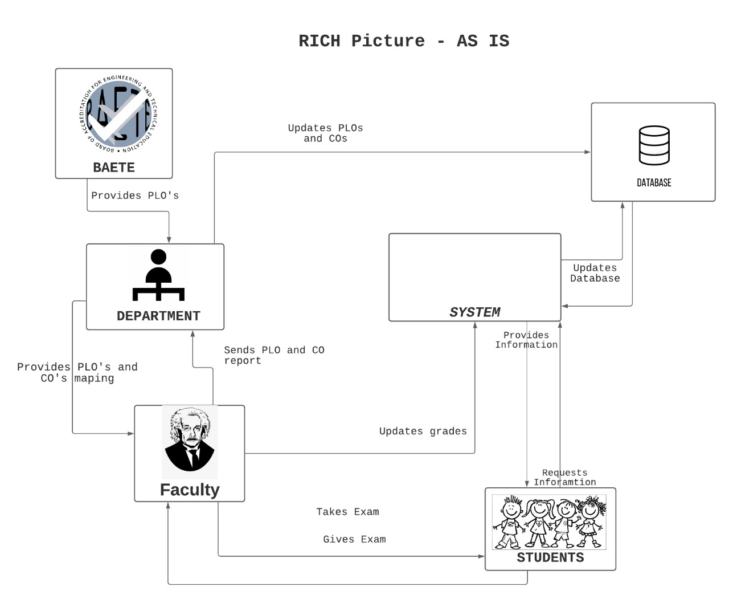

6 ELEMENTS AS_IS

Process | System Roles
Process | Human | non-Computing Hardware | Computing Hardware | Software | Database | Networks and Communication
Provide PLO’s and mapping of CO’s | Department -  1.BAETE sends accreditation manual with PLO’s defined to the department  2. Department  then collects  information  regarding Course  Outcome from BAETE  3. If the course content review the course content else create a list of the course content.  Faculty - Department maps CO’s with PLO’s and sends it to the faculty | Paper- Hard copy file. | Computer & Mobile Phone - All related data is searched and stored using a computer and mobile phone (if necessary) | None | All related  information  is stored in  a specific  location. | All related  data are  searched  through the  internet.
Course Registration | Student-  On the  reserved day for  registration logs in  to system with  their id and  password.  2. Go to the  registration page,  load courses and  select courses.  Can only select  courses of which  prerequisites  have been  completed and  the course  capacity is not  exceeded.  3. If the student misses registration date then the registration has to be done manually within a given time.  4. The student needs to go to their respective assigned faculty for the manual registration.  FACULTY  1. If student misses registration date then the respective faculty will manually register. | Pen &  Paper-  Sometimes course  registration is done  manually. | Computer:  All related  data is  searched and  stored using a computer. | System-  System has  an interface  for doing  registration. | MS SQL  Server-  System is  integrated  with MS  SQL Server.  Other  Sources- .All related  information  are stored in  the specific  location. | Internet-  System is a  web-based  application  and requires  Internet access.
Gather student marks from courses they have enrolled | Faculty-  1. Receives CO’s  to be achieved in  that particular  course.  2. Takes exams  such as  mid-term, final &  project to assess  students in  various course  outcomes.  3. Gather marks  for different  assessments  including student id, course id,  section, semester.  4. Convert the  total marks for  mid-term, final.  5. Calculate total  for all the CO’s. | Pen &  Paper-  1. Written  exams  conducted by  the faculty to  evaluate the  students. | Computer-  1. All related  data such as  student name,  id is searched  and stored  using a  computer.  2. Exams and assessments may also be done using a computer. | MS Excel-  1. All related  information is  stored.  . | Other  Sources-  1. All  related  information  is stored in  the specific  location. | Google Classroom- Used to pass information online
Provide student marks | Faculty:  1. Provides  students total CO  marks achieved  in all CO’s in  mid-term, final &  project.  Department:  1. Gather  students marks in  all CO’s achieved  based on  mid-term, final &  project  2. Calculates CO  percentages.  3. If greater than  or equal to 40%  CO’s have been  achieved, a  student passes  that certain CO  otherwise fails.  4. The  corresponding  CO’s are mapped  against PLO’s  and PLO  Achievements are recorded. | None | Computer:  1. All related  data is  searched and  stored using a  computer. | MS Excel:  1. All related  information is  stored. | Other  Sources:  1. All  related  information  is stored in  the specific  location. | All related  data are  provided  through the  internet.

Give report & Report analysis | Department:  1. Retrieve the  student  information of  PLO  achievement  from previously  calculated OBE  Mark sheet.  2. Make reports  after comparing  results of  multiple students.  3. Calculate pass or fail  percentage  based on the total  number of  students.  BAETE : Does analysis by  1a. Viewing  number of  students passing  or failing in a  certain PLO.  1b. Viewing  progression of  students with  charts and  graphs. | Paper:  1. Paper is  required for  the printing  purpose. | Computer:  1. All related  data is  searched and  stored using a  computer.  Printer:  1. Print the  report based  on users’  request. | MS Excel:  1. All related  information is  stored and  calculated. | Other  Sources:  1. All  related  information  is stored in  the specific  location. | None

Process Diagram ( AS IS ):
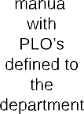
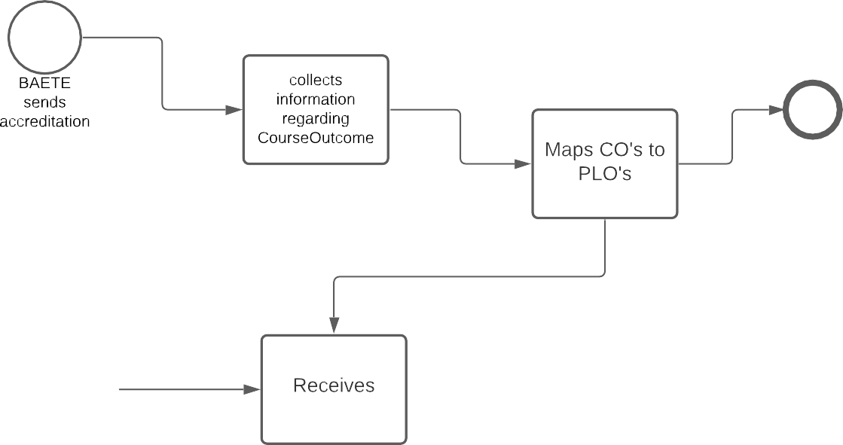
Provide PLO’s and mapping of CO’s

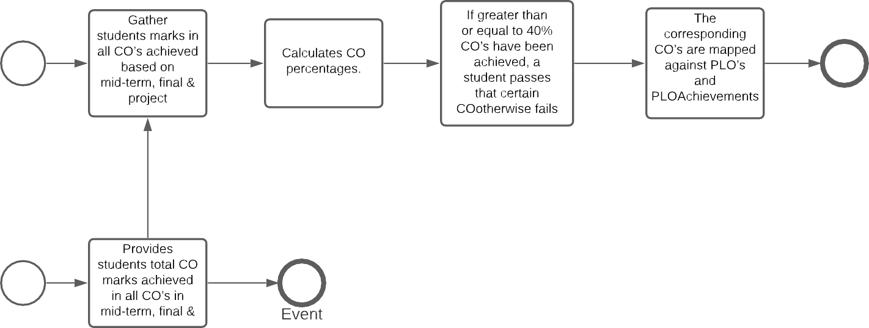

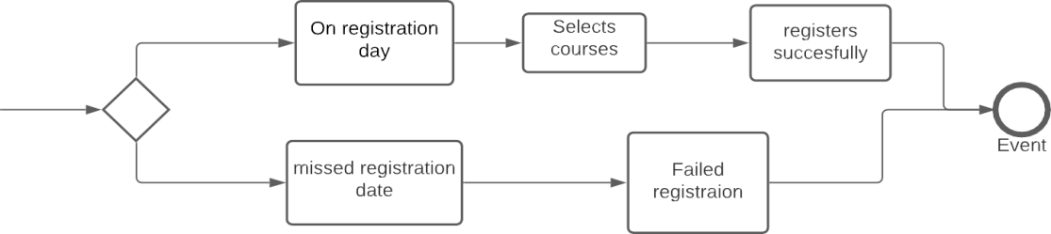
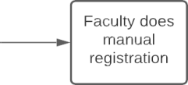

Course Registration

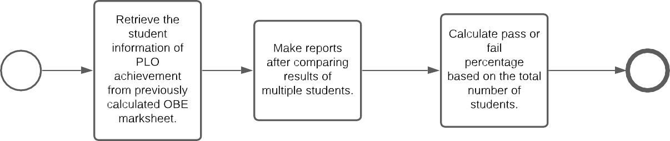
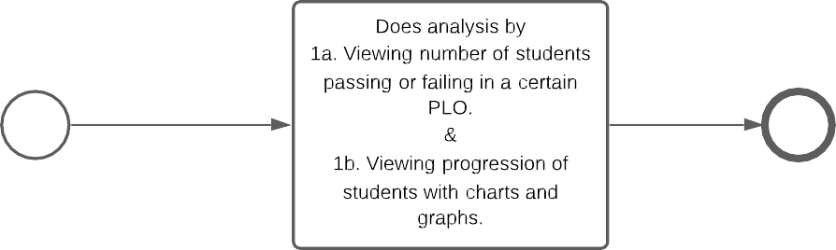

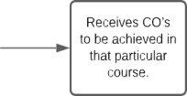
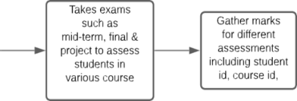
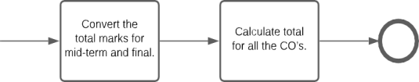
Gather student marks from courses they have enrolled

PROBLEM ANALYSIS :

Process | Stakeholders | Concerns (Problems) | Analysis (Reason of the Problem) | Proposed Solution
Faculty members submit COs to Admin after evaluating students and Admin update the COs to Excel Database | 1. Faculty Members | The process of Faculty members passing COs data to Admin and Admin entering the data to excel database is time consuming. | When data  is on the process to be passed from the  faculty to the Admin, it takes a lot of time and it also takes extra resources. | Faculty members can directly update the COs on the database without involving Admin if software is directly accessible to them.
CO Entry and Mapping | 1. IUB Faculties  2. Admin | Admin update the COs data to the excel  database after faculties mapped PLO to COs for each course and send it to the Admin | Depending on the change each semester, faculties will have to send the mapped COs to Admin, and it is time consuming. | Since SPM contains  the PLOs,  faculties can  directly map the COs from their own  account
Based on CO and PLO, UGC approves the curriculum | 1. Higher  Management (HM)  2. UGC | Whenever there is an update on curriculum, HM will have to send it to the department. This process is also manual. | The process of the approval of UGC after receiving the curriculum is time consuming. Also manually updating curriculum every time is inefficient. | If the curriculum is accessible through software, faculty members and HM can update it in real time whenever required by the UGC.
Maintenance | 1. IUB Faculties  2. Admin | Harder to maintain/replace/correct information. | Things are done manually so the main thing must do again if anything must be modified | Everything is stored in database which is easier to up  Date

Rich Picture – To Be :

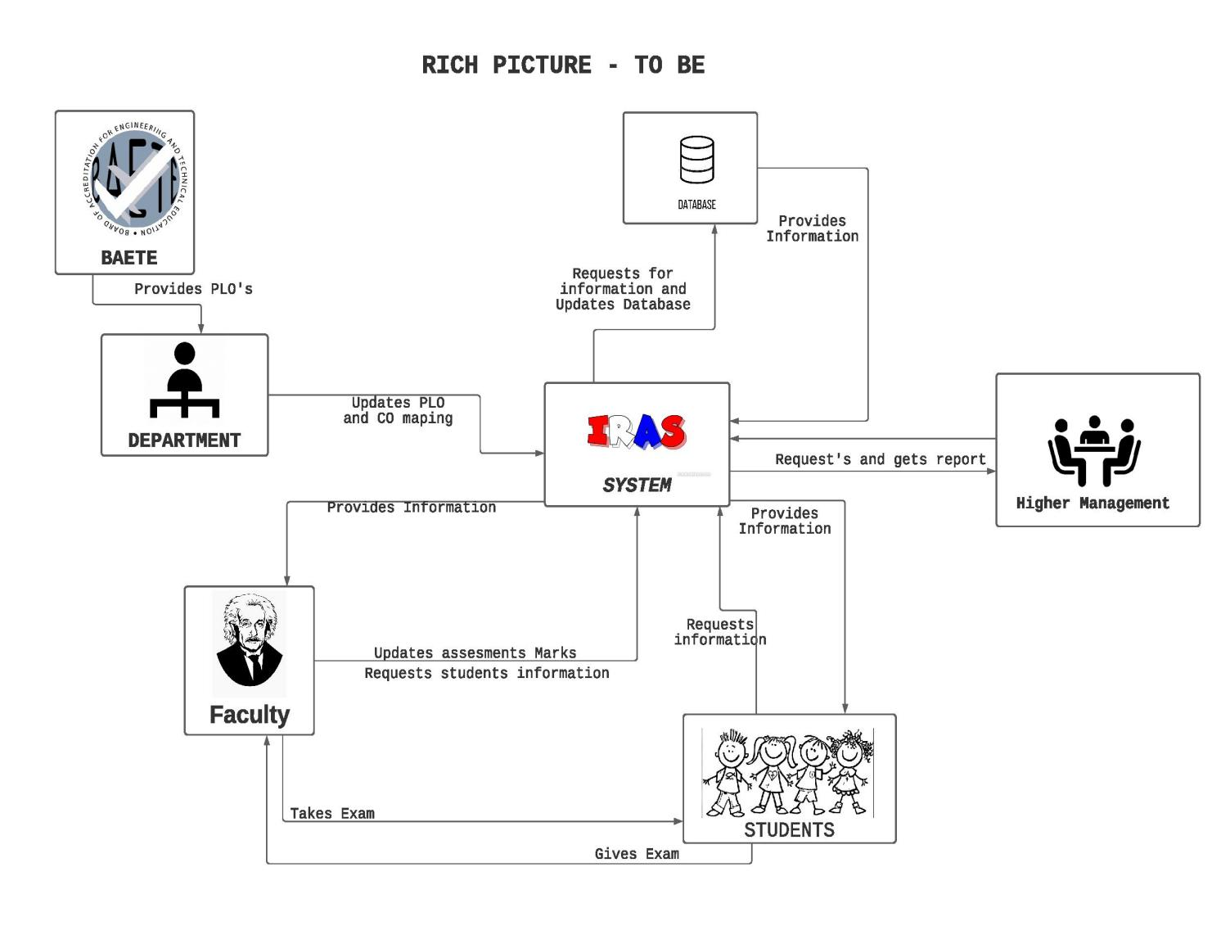

Six Elements TO BE:

Process | System Rules
Process | Human | Non-Computing Hardware | Computing Hardware | Software | Database | Network & Communication
Updates PLO and CO mapping | BAETE-  Provide PLO to the department .  Department - Update PLO and CO mapping to system. | Paper- Hard copy file | Computer & Mobile Phone - All related data is searched and stored using a computer and mobile phone (if necessary | None | All related Information is stored in a specific location | All related data are Searched through the internet.
Request and provide report | Higher management - sends requests to the system for reports | Paper- Hard copy file | Computer & Mobile Phone - All related data is searched and stored using a computer and mobile phone (if necessary | None | All related Information is stored in a specific location | All related data are Searched through the internet.
Update assessment | Faculty-  1. Takes exams such as mid-term, final & project to assess students in various course outcomes.  2. Gather marks for different assessments including student id, course id,section, semester.  Student :  a) Sit for the examinations and submit the script papers to faculty. | Pen & Paper-  1. Written exams conducted by the faculty to evaluate the students. | Computer-  1. All related data such as student name, id is searched and stored using a computer.  2. Exams and assessments may also be done using a computer | MS Excel-  1. All related information is stored. | Other Sources-  1. All related information is stored in the specific location. | Google Classroom- Used to pass information online
Request to the system for transcript | Faculty - 1.Provides the system with updated assessment marks.  2. Get the updated information.  Student- Get their transcript from the system. | Paper- Hard copy file | Computer & Mobile Phone - All related data is searched and stored using a computer and mobile phone (if necessary | None | All related Information is stored in a specific location | All related data are Searched through the internet

PROCESS DIAGRAM TO BE:
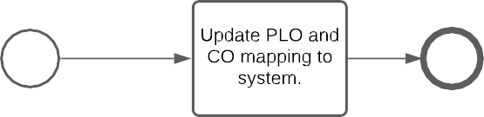
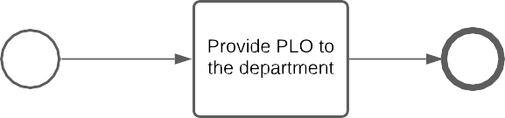

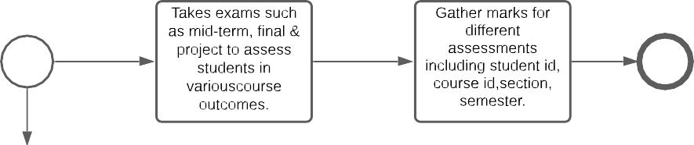
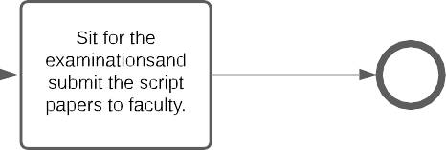

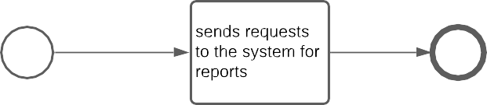

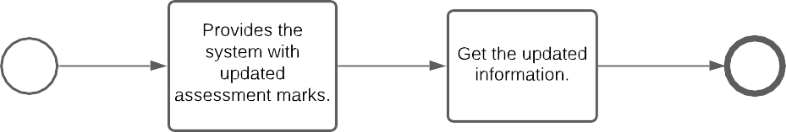
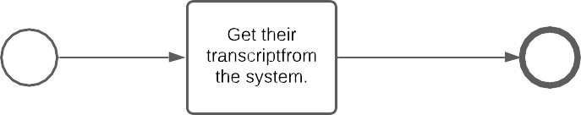

CHAPTER 3
LOGICAL SYSTEM DESIGN
● BUSINESS RULE
● ENTITY RELATIONSHIP DIAGRAM
● ENTITY RELATIONSHIP DIAGRAM
TO RELATIONAL SCHEMA
● NORMALIZATION
● DATA DICTIONARY

BUSINESS RULE:
The goal of the software is to increase efficiency in monitoring the students performance. The SPM system is where all the PLO(Program Learning Outcome) and CO(Course Outcome) is stored. The CO is needed to be updated by the faculty for each course and before the semester starts to map the COs to the PLOs so that they can check if each student has achieved the required PLOs.
In the system, IEB has no authorization to update the PLOs, so it has to send it to the Admin and then the Admin updates the PLO for the faculties to map. The faculties can update the COs based on the given PLOs. The students can view their achieved PLOs for a particular course they've taken and see the required PLOs for the program in the system UGC has no authorization in monitoring the students performance so they have to request it through admin in order to view it.

ENTITY RELATIONSHIP DIAGRAM:

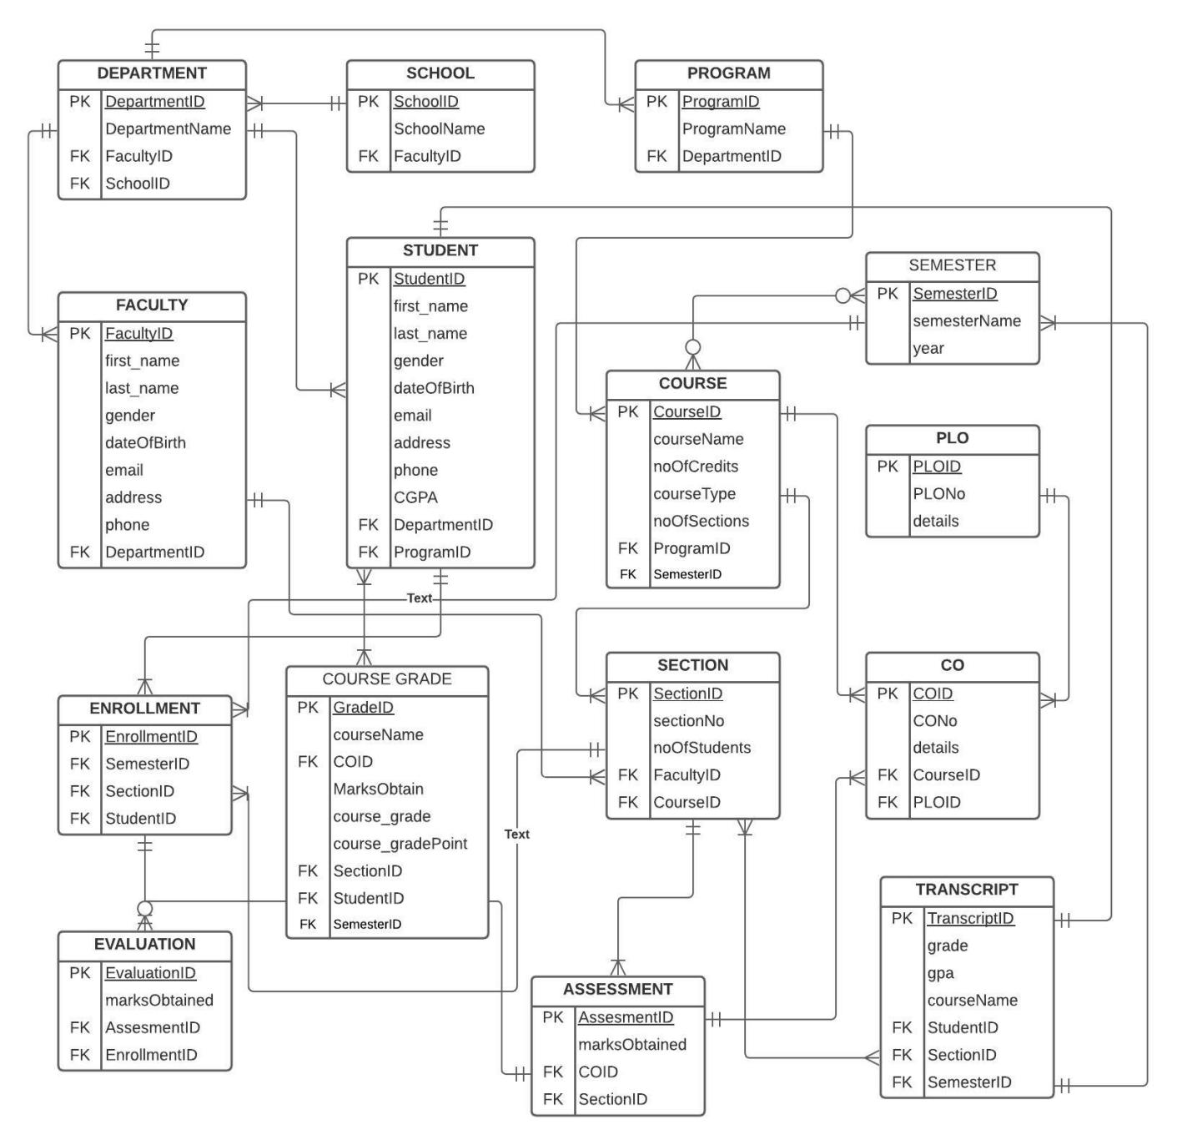

ENTITY RELATIONSHIP DIAGRAM TO RELATIONAL SCHEMA
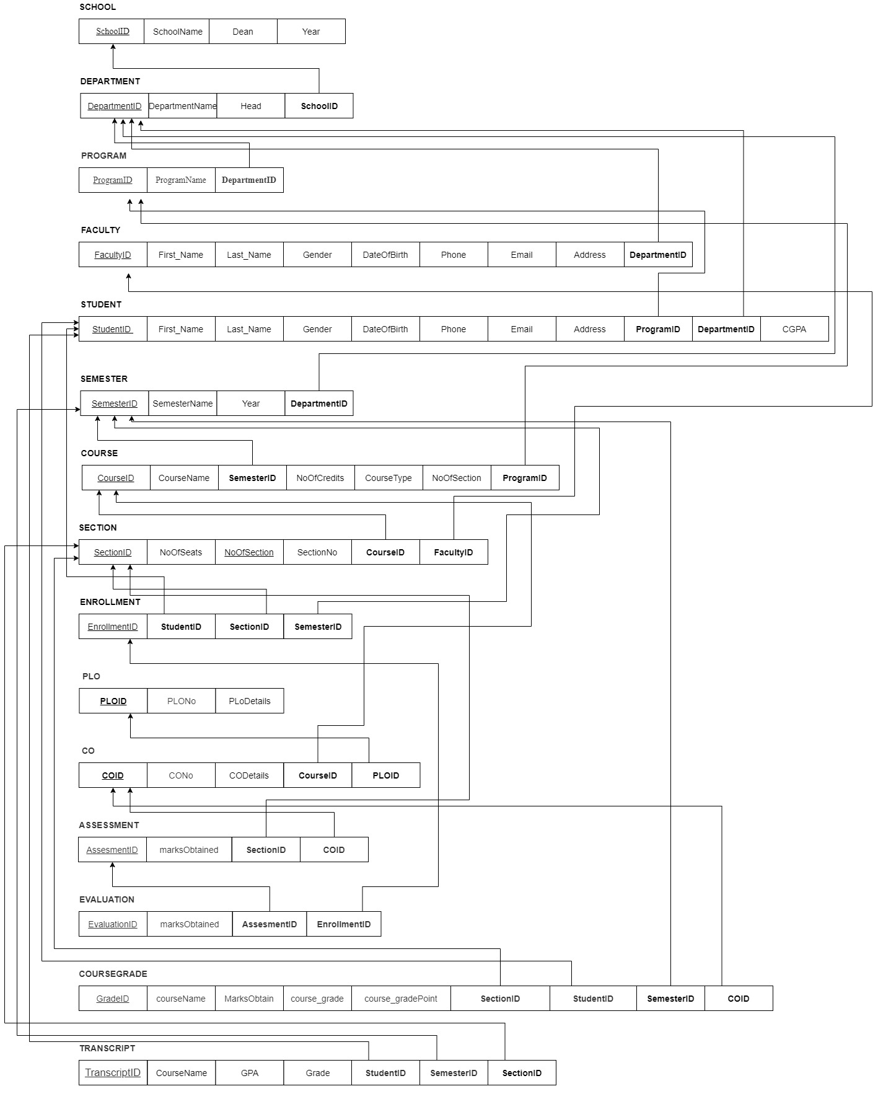
NORMALIZATION:

Department | DepartmentID | d1 | Course | CourseID | o1
Department | DepartmentName | d2 | Course | CourseName | o2
Department | Head | d3 | Course | noOfCredits | o3
Department | SchoolID | s1 | Course | courseType | o4
School | SchoolID | s1 | Course | noOfSections | o5
School | SchoolName | s2 | Course | ProgramID | r1
School | Dean | s3 | Semester | SemesterID | b1
Program | ProgramID | r1 | Semester | semesterName | b2
Program | ProgramName | r2 | Semester | year | b3
Program | DepartmentID | d1 | Semester | CourseID | o1
Faculty | FacultyID | f1 | PLO | PLOID | p1
Faculty | first_name | f2 | PLO | PLONo | p2
Faculty | last_name | f3 | PLO | details | p3
Faculty | gender | f4 | PLO | ProgramID | r1
Faculty | dateOfBirth | f5 | Enrollment | EnrollmentID | e1
Faculty | email | f6 | Enrollment | SemesterID | b1
Faculty | address | f8 | Enrollment | SectionID | q1
Faculty | phone | f7 | Enrollment | StudentID | t1
Faculty | DepartmentID | d1 | CO | COID | c1
Student | StudentID | t1 | CO | CONo | c2
Student | first_name | t2 | CO | details | c3
Student | last_name | t3 | CO | CourseID | o1
Student | gender | t4 | CO | PLOID | p1
Student | dateOfBirth | t5 | Transcript | TranscriptID | u1
Student | email | t6 | Transcript | grade | u2
Student | address | t8 | Transcript | gpa | u3
Student | phone | t7 | Transcript | courseName | u4
Student | CGPA | t9 | Transcript | StudentID | t1
Student | DepartmentID | d1 | Transcript | SectionID | q1
Student | ProgramID | r1 | Transcript | SemesterID | b1
Assessment | AssesmentID | a1 | Evaluation | EvaluationID | v1
Assessment | marksObtained | a2 | Evaluation | marksObtained | v3
Assessment | COID | c1 | Evaluation | evaluationNo | v2
Assessment | SectionID | q1 | Evaluation | AssesmentNo | a1
Section | SectionID | q1 | Evaluation | EnrollmentID | e1
Section | sectionNo | q2
Section | semester | q3
Section | noOfStudents | q4
Section | FacultyID | f1
Section | CourseID | o1

d1➔ | d2, d3, s1
s1➔ | s2, s3
r1➔ | r2, d1
f1➔ | f2, f3, f4, f5, f6, f7, f8, d1
t1➔ | t2, t3, t4, t5, t6, t7, t8, t9 d1, r1
o1➔ | o2, o3, o4, o5, r1
b1➔ | b2, b3, o1
p1➔ | p2, p3, r1
c1➔ | c2, c3, o1, p1
q1➔ | q2, q3, q4, f1, o1
e1➔ | b1, q1, t1
u1➔ | u2, u3, u4, b1, q1, t1
a1➔ | a2, c1, q1
v1➔ | v2, v3, a1, e1

DepartmentID➔ | DepartmentName, Head, SchoolID
SchoolID➔ | SchoolName, Dean
ProgramID➔ | programName, DepartmentID
FacultyID➔ | first_name, last_name, gender, dateOfBirth, email, phone, address, DepartmentID
StudentID➔ | first_name, last_name, dateOfBirth, gender, email, phone, address, CGPA, DepartmentID, ProgramID
CourseID➔ | courseName, noOfCredits, courseType, noOfSections, ProgramID
SemesterID➔ | semesterName, year, CourseID
PLOID➔ | PLONo, details, ProgramID
COID➔ | CONo, details, CourseID, PLOID
SectionID➔ | sectionNo, semester, CourseID, FacultyID
EnrollmentID➔ | SemesterID, SectionID, StudentID
assessmentNo➔ | marksObtained, ocID, SectionID
EvaluationID➔ | evaluationNo, obtainedMarks, assesmentNo, EnrollmentID

DATA DICTIONARY:

SCHOOL
Name | Data Type | Size | Remark
SchoolID | INT | 10 | This is the Primary Key of School  Example: “1,2,3,4”
SchoolName | VARCHAR | 50 | This is the name of the School.  Example: “School of Engineering, Technology  and Science”

DEPARTMENT
Name | Data Type | Size | Remark
DepartmentID | INT | 10 | This is the Primary Key of the Department.  Example: “CSE”
DepartmentName | VARCHAR | 25 | This is the name of the Department.  Example: “Computer Science and Engineering”
SchoolID | INT | 10 | This is the Foreign Key of the table School.  Example: “1,2,3,4”

FACULTY
Name | Data Type | Size | Remark
FacultyID | INT | 10 | This is the Primary Key for Faculty.  Example: “2506”
first_name | VARCHAR | 15 | This is the first name of the Faculty.  Example: “Abu”
last_name | VARCHAR | 15 | This is the last name of the Faculty  Example: “Sayed”
gender | VARCHAR | 10 | This is the gender of the Faculty .  Example: “M”
dateofBirth | DATE | DD-MM-YYYY | This the Date of Birth of the Faculty.  Example: “20-12-1980”
email | VARCHAR | 15 | This is the email address of the Faculty.  Example: “abusayed@iub.edu.bd”
address | VARCHAR | 30 | This is the address of the Faculty.  Example: “House 39, Road 15, Sector 12, Uttara,  Dhaka, Bangladesh”
phone | INT | 15 | This is the phone number of the Faculty.  Example: “01689656497”
DepartmentID | INT | 10 | This is the Foreign Key from the Department  table.  Example: “CSE”

PROGRAM
Name | Data Type | Size | Remark
ProgramID | INT | 10 | This is the Primary Key for a Program  Example: ”B.Sc”.
ProgramName | VARCHAR | 50 | This is the name of the Degree Program.  Example: “Bachelor of Science”
DepartmentID | INT | 10 | This is the Foreign Key from the Department  table.  Example: “CSE”

STUDENT
Name | Data Type | Size | Remark
StudentID | INT | 10 | This is the Primary Key for the Student.  Example: “1811111”
first_name | VARCHAR | 15 | This is the first name of the Student.  Example: “Tonmoy”
last_name | VARCHAR | 15 | This is the last name of the Student.  Example: “Tahsin”
gender | VARCHAR | 10 | This is the gender of the Student.  Example: “M”
dateOfBirth | DATE | DD/MM/YYYY | This the Date of Birth of the Student.  Example: “08-05-1998”
email | VARCHAR | 15 | This is the email address of the Student.  Example: “1811111@iub.edu.bd”
address | VARCHAR | 30 | This is the address of the Student.  Example: “House 14, Road 2, Bashundhara R/A,  Dhaka, Bangladesh”
phone | INT | 15 | This is the phone number of the Student.  Example: “01645467909”
cgpa | NUMERIC | 5 | This is the Cumulative GPA of the student.  Example: “ 3.65”
DepartmentID | INT | 10 | This is the Foreign Key from the Department  table.  Example: “CSE”
ProgramID | INT | 10 | This is the Foreign Key from Program table  Example: ”B.Sc”.
SchoolID | INT | 10 | This is the Foreign Key from School table  Example: ”SETS”.

SEMESTER
Name | Data Type | Size | Remark
SemesterID | INT | 10 | This is the Primary key of the semester.  example : “1”
semesterName | VARCHAR | 50 | This is the name of Semester.  Example: “Spring 2021”

COURSE
Name | Data Type | Size | Remark
CourseID | INT | 10 | This is the Primary Key for the Course.  Example: “CSE303”
courseName | VARCHAR | 15 | This is the name of the Course.  Example: ”Database management system”
courseType | VARCHAR | 10 | This is the type of the Course.  Example: “Major”
noOfCredits | INT | 1 | This is the credit for the Course.  Example: ”4”
noOfSections | INT | 2 | This is the total number of section.  Example : “3”
SemesterID | INT | 10 | This is the Foreign Key from Semester table  Example: ”B.Sc”.
ProgramID | INT | 10 | This is the Foreign Key from Program table  Example: ”B.Sc”.

SECTION
Name | Data Type | Size | Remark
SectionID | INT | 10 | This is the Primary Key for Section
sectionNo | INT | 2 | This is the section number.  Example: “1”
noOfStudents | INT | 3 | This is the total number of students enrolled.  Example: “40”
SemesterID | INT | 10 | This is the foreign Key from the Semester table.  Example: “1”
FacultyID | INT | 10 | This is the foreign Key from the Faculty table.  Example: “2501”
CourseID | INT | 10 | This is the foreign Key from the Course Table  Example: “CSE303
StudentID | INT | 10 | This is the foreign Key from the Student table.  Example: “1811111”

ENROLLMENT
Name | Data Type | Size | Remark
EnrollmentID | INT | 10 | This is the Primary Key for Enrollment.
SemesterID | INT | 10 | This is the foreign Key from the Semester table.  Example: “1”
SectionID | INT | 10 | This is the Foreign Key from SectionID
StudentID | INT | 10 | This is the foreign Key from the Student table.  Example: “1811111”

EVALUATION
Name | Data Type | Size | Remark
EvaluationID | INT | 10 | This is the Primary Key for Evaluation
marksObtained | INT | 3 | This is the marks obtained by the Student  Example: “45.5”
AssessmentID | INT | 10 | This is the Foreign Key from Assessment table
EnrollmentID | INT | 10 | This is the Foreign Key from Enrollment table

ASSESSMENT
Name | Data Type | Size | Remark
AssessmentID | INT | 10 | This is the Primary Key for Enrollment
marksObtained | INT | 3 | This is the semester of Enrollment  Example: “Summer”
COID | INT | 10 | This is the Foreign Key from the Course  Outcome table  Example:
SectionID | INT | 10 | This is the Foreign Key from the Section table.
StudentID | INT | 10 | This is the Foreign Key from the Student table.
SemesterID | INT | 10 | This is the Foreign Key from the Semester table.

CourseGrade
Name | Data Type | Size | Remark
GradeID | INT | 10 | This is the Primary Key of CourseGrade table.
StudentID | INT | 10 | This is the Foreign Key from Student table
SemesterID | INT | 10 | This is the Foreign Key from Semester table
SectionID | INT | 10 | This is the Foreign Key from Section table
FacultyID | INT | 10 | This is the Foreign Key from Faculty table
CourseName | VARCHAR | 10 | This is the name of the Course.  Example: ”Database management system”
ProgramID | INT | 10 | This is the Foreign Key from Program table
DepartmentName | VARCHAR | 10 | This is the name of the Department.  Example: “Computer Science and Engineering”
SchoolName | VARCHAR | 10 | This is the name of the School.  Example: “School of Engineering, Technology and Science”
CourseGrade | CHAR | 1 | This is the grade of the course.  Example: “B+”
CourseGradePoint | NUMERIC | 10 | This is the grade point of the course.  Example : 3.33

TRANSCRIPT

Name | Data Type | Size | Remark
TranscriptID | INT | 10 | TranscriptID represent different transcript data.  Examole: TranscriptID=”2341”
grade | VARCHAR | 2 | Grade represents individual grades of courses.  Example : “B+”
gpa | NUMERIC | 5 | GPA represents individual gpa .  Example : “4.00”
CourseName | VARCHAR | 10 | This is the name of the Course.  Example: ”Database management system”.
StudentID | INT | 10 | This is the Foreign Key from Student table.
SemesterID | INT | 10 | This is the Foreign Key from Semester table.
SectionID | INT | 10 | This is the Foreign Key from Section table.

PLO
Name | Data Type | Size | Remark
PLOID | INT | 10 | Unique representation ID of each PLO  Example: “PLO1”
PLONo | varchar | 5 | This is the number of Program Learning Outcomes.
PLODetails | varchar 30 | 30 | This is the details of the Program Learning  Outcome.  Example: “An ability to select and apply the  knowledge, techniques, skills, and modern  tools of the computer science and  engineering discipline”
ProgramID | INT | 10 | This is the Foreign Key from the program table.

CO

Name | Data Type | Size | Remark
COID | INT | 10 | Unique representation ID of each CO  Example: “CO1”
CONo’ | varchar | 5 | This is the number of the Course Outcome.  Example: ”1”
CODetails | varchar | 30 | This is the details of course outcomes.  Examples: “CO1,CO2”
CourseID | INT | 10 | This is the Foreign Key form Course table.
PLOID | INT | 10 | This is the Foreign Key from PLO table.

CHAPTER 4
PHYSICAL SYSTEM DESIGN
● INPUT FORMS
● OUTPUT FORMS

INPUT FORMS
Enrollment Data Entry for Assessment
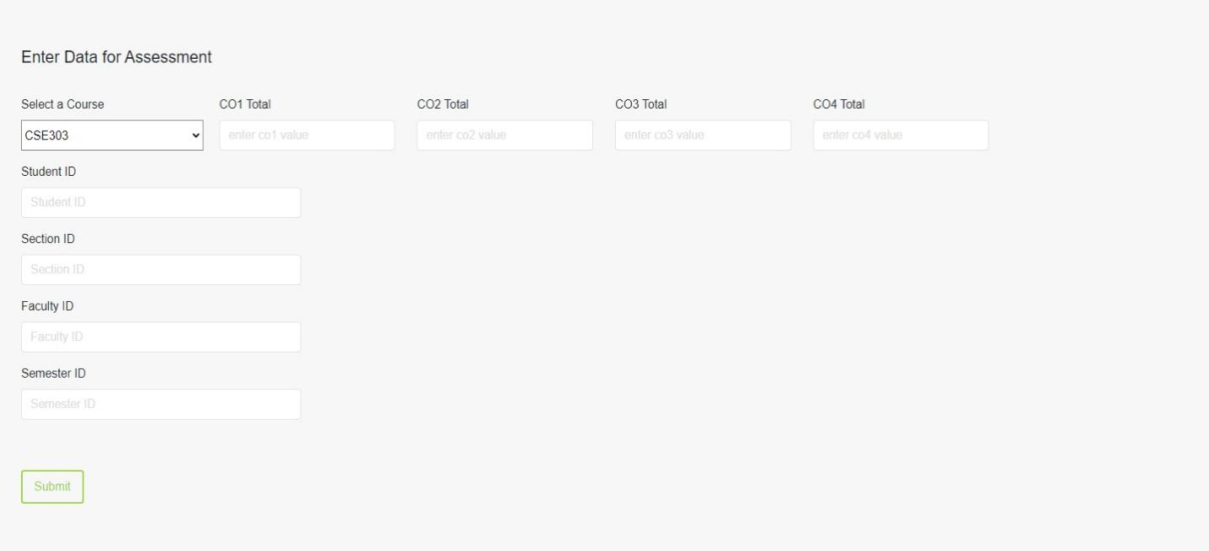
app.post("/assessment", (req, res) => {
const courseName = JSON.stringify(req.body.course);
const CO1 = req.body.co1;
const CO2 = req.body.co2;
const CO3 = req.body.co3;
const CO4 = req.body.co4;
const semesterID = req.body.semesterID;
const sectionID = req.body.sectionID;
const studentID = req.body.studentID;
const facultyID = req.body.facultyID;

const sqlInsert = `INSERT INTO spm.course_grade (studentID, courseName, CO1, CO2, CO3, CO4, facultyID, sectionID) VALUES (${studentID}, ${courseName}, ${CO1}, ${CO2}, ${CO3}, ${CO4}, ${facultyID}, ${sectionID});`;
db.query(sqlInsert, (err, result) => {
if (err) {
res.send("Failed to upload assessment data");
} else {
res.send("Assessment data uploaded successfully"); }
});
});
PLO-CO Mapping
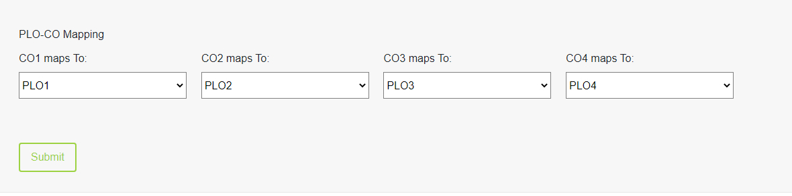

app.post("/ploCoMapping", (req, res) => {
const id = req.body.courseID;
const progID = req.body.programID;
const credits = req.body.noOfCredits;
const coList = req.body.mappedCoList;
const course = spm.course(id, progID, credits);
course.save();

coList.map((co, index) => {
co = spm.CO(
(spm.CoNo = index + 1),
(courseID = id),
(PLOID = coList[index])
);
co.save();
});
});

Couse-wise Student GPA

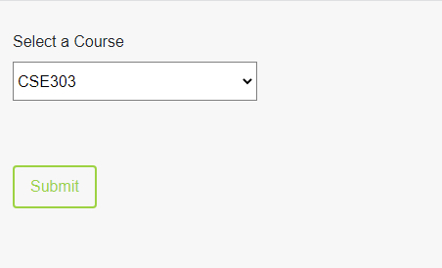

app.post("/course/studentGrades", (req, res) => {
var c = JSON.stringify(req.body.course);
const grades = `SELECT R.studentID, R.courseName, R.grade
FROM spm.course_grade R
WHERE R.courseName = ${c}`;

db.query(grades, (err, result) => {
res.send(result);
});
});

Faculty-wise Student GPA

app.post("/faculty/studentGrades", (req, res) => {
const sqlInsert = `
SELECT f.facultyId, CONCAT(f.first_name, " ", f.last_name) AS FacultyName,
s.courseName, s.studentID, s.grade
FROM spm.faculty f
LEFT JOIN spm.course_grade s ON f.facultyID = s.facultyID
WHERE f.facultyID = ${req.body.facultyID}`;

db.query(sqlInsert, (err, result) => {
res.send(result);
});
});

app.post("/faculty/studentGrade", (req, res) => {
const sqlInsert = `SELECT f.facultyId, CONCAT(f.first_name, " ", f.last_name) AS FacultyName,
s.courseName, s.studentID, s.grade
FROM spm.faculty f
LEFT JOIN spm.course_grade s ON f.facultyID = s.facultyID
WHERE f.facultyID = ${req.body.facultyID} AND s.studentID = ${req.body.studentID};`;

db.query(sqlInsert, (err, result) => {
res.send(result);
});
});

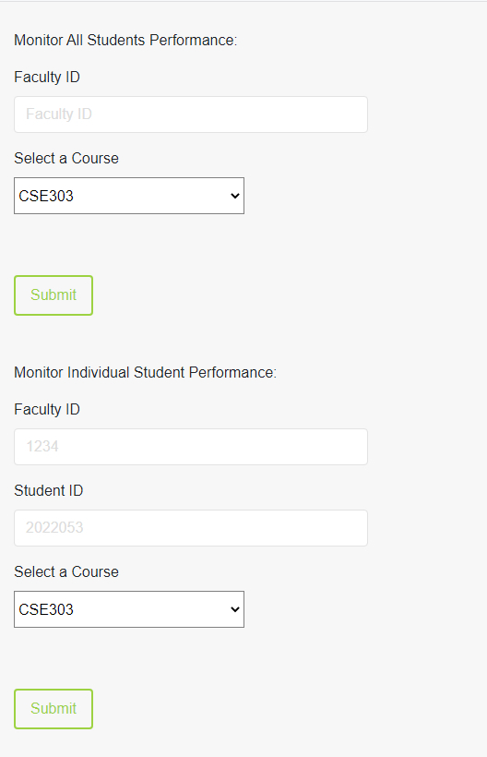

Dean-wise Student GPA
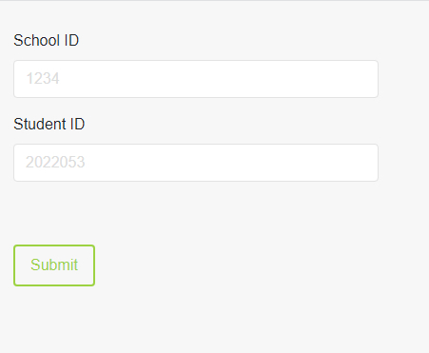

app.post("/dean/studentGrades", (req, res) => {
const sqlInsert = `select s.dean, t.studentID, c.grade
FROM spm.school s LEFT JOIN spm.student t ON t.schoolID = s.schoolID
INNER JOIN spm.course_grade c ON c.studentID = t.studentID
WHERE t.studentID = ${req.body.studentID}
AND s.schoolID = ${req.body.schoolID};`;

db.query(sqlInsert, (err, result) => {
res.send(result);
});
});

OUTPUT FORMS
School-wise Enrollment
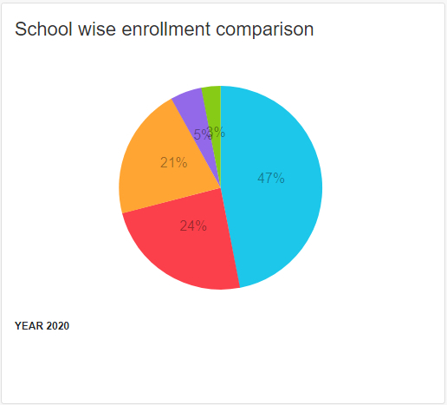
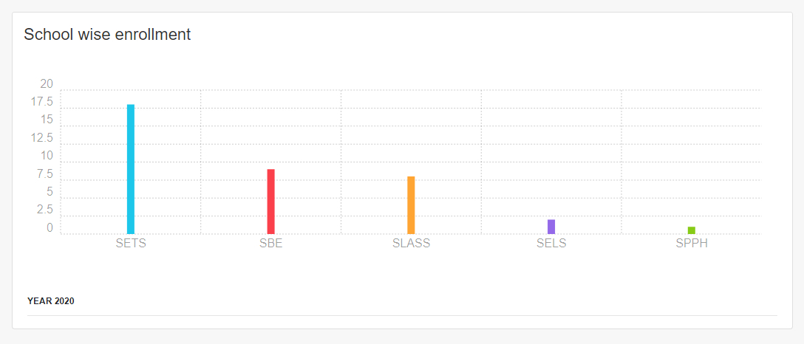
app.get("/school/enrollment", (req, res) => {
const sqlInsert =
"SELECT d.schoolName, COUNT(s.studentID) as noOfStudents,
CONCAT(c.semesterName, ' ', c.year) AS Semester FROM spm.school d
LEFT JOIN spm.student s ON d.schoolID = s.schoolID
INNER JOIN spm.semester c ON c.semesterID = d.semesterID
GROUP by d.schoolID ORDER by COUNT(s.studentID) DESC, d.schoolName ASC";
db.query(sqlInsert, (err, result) => {
res.send(result);
});
});

Program-wise Enrollment
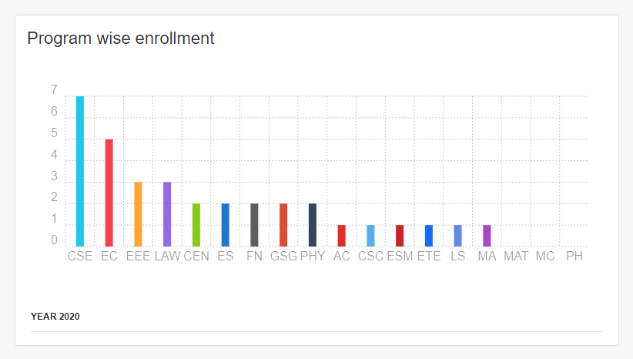

app.get("/program/enrollment", (req, res) => {
const sqlInsert =
"SELECT d.programName, COUNT(s.studentID) as noOfStudents,
CONCAT(c.semesterName, ' ', c.year) AS Semester
FROM spm.program d
LEFT JOIN spm.student s ON d.programID = s.programID
INNER JOIN spm.semester c ON c.semesterID = d.semesterID
GROUP by d.programID
ORDER by COUNT(s.studentID) DESC, d.programName ASC";

db.query(sqlInsert, (err, result) => {
res.send(result);
});
});

Department-wise Enrollment
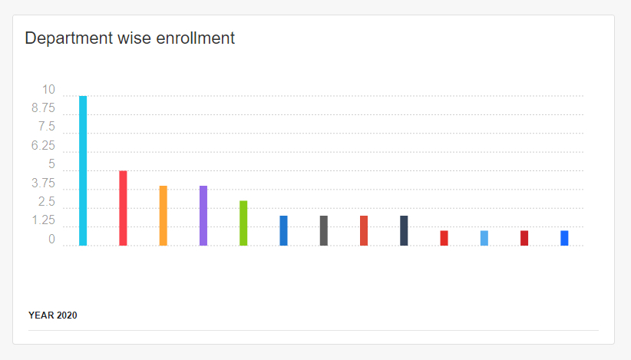

app.get("/department/enrollment", (req, res) => {
const sqlInsert =
"SELECT d.departmentName, COUNT(s.studentID) AS noOfStudents,
CONCAT(c.semesterName, ' ', c.year) AS Semester
FROM spm.department d
LEFT JOIN spm.student s ON d.departmentID = s.departmentID
INNER JOIN spm.semester c ON c.semesterID = d.semesterID
GROUP by d.departmentID
ORDER by COUNT(s.studentID) DESC, d.departmentName ASC";

db.query(sqlInsert, (err, result) => {
res.send(result);
});
});

School-wise CGPA

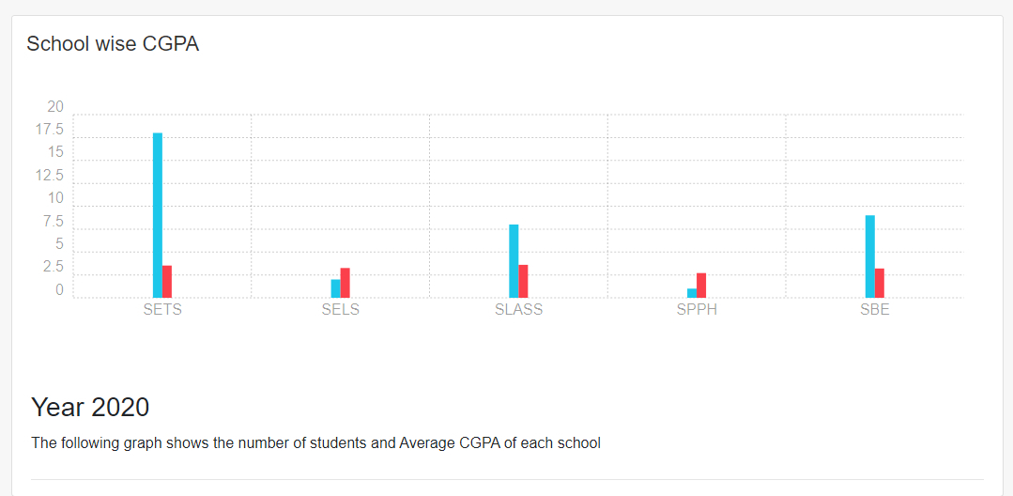

app.get("/school/CGPA", (req, res) => {
const sqlInsert = `SELECT s.schoolName, ROUND(AVG(t.CGPA), 2) AS AVG_CGPA,
COUNT(t.studentID) as noOfStudents
FROM spm.school s
JOIN spm.student t ON t.schoolID = s.schoolID
GROUP BY s.schoolName;`;

db.query(sqlInsert, (err, result) => {
res.send(result);
});
});

Program-wise CGPA

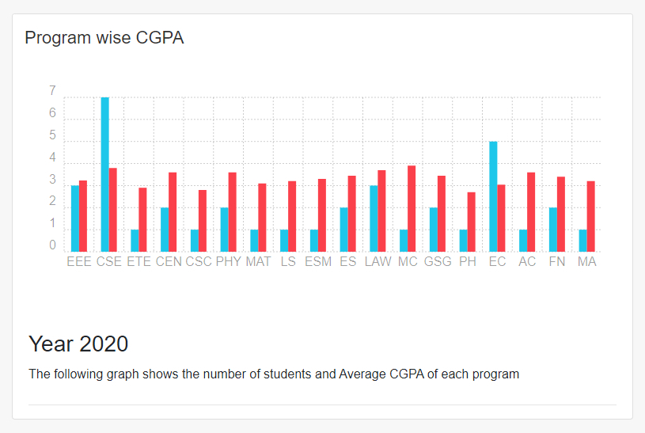

app.get("/program/CGPA", (req, res) => {
const sqlInsert = `SELECT s.programName, ROUND(AVG(t.CGPA), 2) AS AVG_CGPA,
COUNT(t.studentID) as noOfStudents
FROM spm.program s
JOIN spm.student t ON t.programID = s.programID
GROUP BY s.programName;`;

db.query(sqlInsert, (err, result) => {
res.send(result);
});
});

Department-wise CGPA

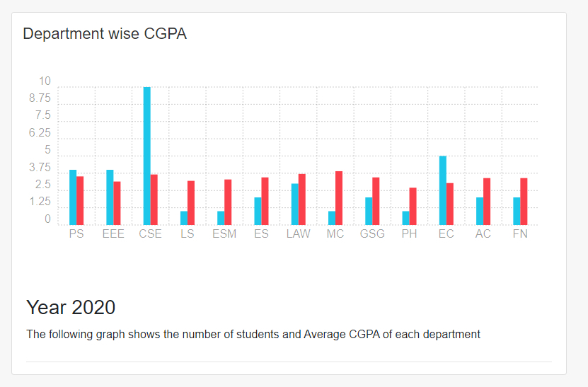

app.get("/department/CGPA", (req, res) => {
const sqlInsert = `SELECT s.departmentName, ROUND(AVG(t.CGPA), 2) AS AVG_CGPA, COUNT(t.studentID) as noOfStudents
FROM spm.department s
JOIN spm.student t ON t.departmentID = s.departmentID
GROUP BY s.departmentName;`;

db.query(sqlInsert, (err, result) => {
res.send(result);
});
});

PLO Achievement Percentage Table

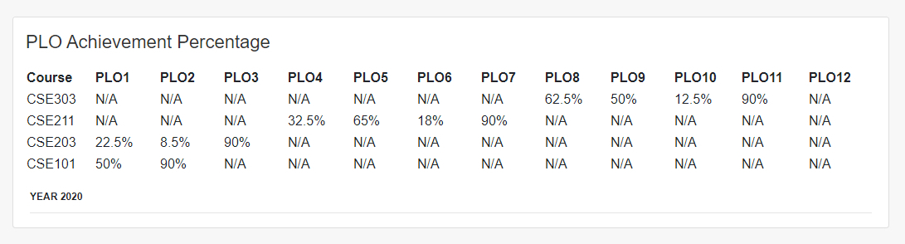

SELECT DISTINCT co.courseID, co.CONo, p.PLONo, (PLO / CoTotal * 100) AS
PLOpercentage
FROM spm.PLO p, spm.CO co, (
SELECT DISTINCT c.courseID, c.CONo, c.PLOID, SUM(DISTINCT
e.marksObtained) AS PLO, SUM(DISTINCT a.marksObtained) AS CoTotal
FROM spm.enrollment en,
spm.evaluation e,
spm.assessment a,
spm.CO c,
spm.PLO p
WHERE en.studentID = 2022053
AND en.enrollmentID = e.enrollmentID
AND e.assessmentID = a.assessmentID
AND c.PLOID = p.PLONO
AND a.COID = c.COID
GROUP BY en.sectionID, c.PLOID
ORDER BY c.PLOID
) perPLO
WHERE co.CONo = perPLO.CONo
AND p.PLONo = perPLO.PLOID
AND co.courseID = perPLO.courseID;

Student-wise PLO

SELECT AVG(TotalPlo.PLOpercentage) AS ActualPlo
FROM (
SELECT (PLO / COTotal * 100) AS PLOpercentage
FROM (
SELECT SUM(DISTINCT e.marksObtained) AS PLO, SUM(DISTINCT

a.marksObtained) AS CoTotal
FROM spm.enrollment en,
spm.evaluation e,
spm.assessment a,
spm.co c,

spm.plo p
WHERE en.studentID = {}
AND e.assessmentID = a.assessmentID
AND en.enrollmentID = e.enrollmentID
AND a.COID = c.COID
AND c.PLOID = {}
GROUP BY en.sectionID
) perPLO
) TotalPlo;

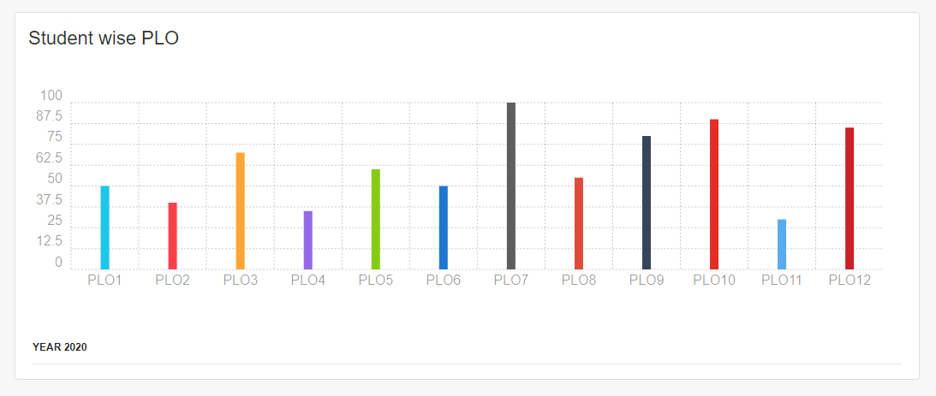

Department-wise PLO

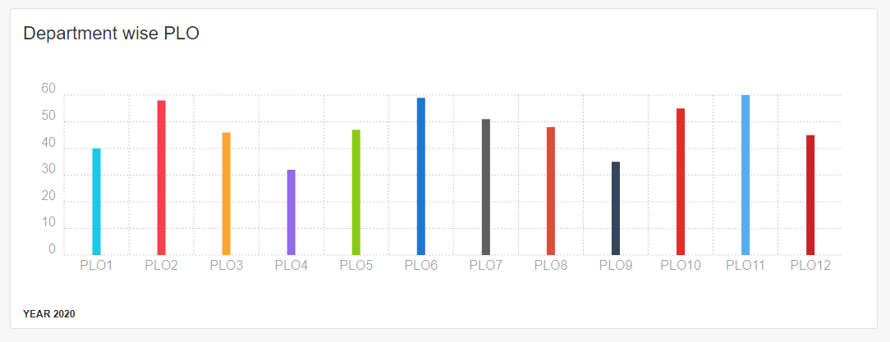

SELECT AVG(PLOTotal.PLOpercentage) AS ActualPlo
FROM (
SELECT (PLO / COTotal * 100) AS PLOpercentage
FROM (
SELECT SUM(e.marksObtained) AS PLO, SUM(a.marksObtained) AS
COTotal
FROM spm.enrollment en,
spm.evaluation e,
spm.assessment a,
spm.co c,
spm.plo p,
spm.student st
WHERE st.departmentID = 100
AND st.studentID = en.studentID
AND e.assessmentID = a.assessmentID
AND en.enrollmentID = e.enrollmentID
AND a.COID = c.COID
AND c.PLOID = 1
GROUP BY en.sectionID
) perPLO
) PLOTotal;

Course-wise PLO

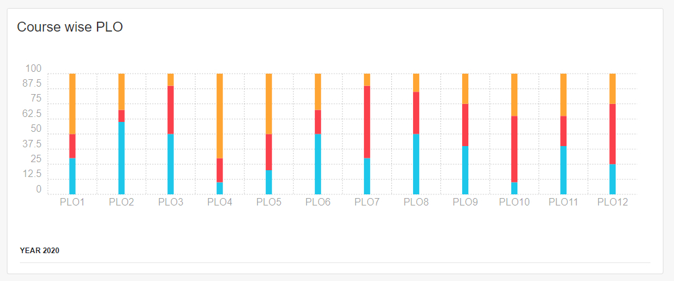

SELECT DISTINCT co.courseID, co.CONo, p.PLONo, (PLO / TotalCO * 100) AS
PLOpercentage
FROM spm.PLO p, spm.CO co, (
SELECT DISTINCT c.courseID, c.CONo, c.PLOID, SUM(DISTINCT
e.marksObtained) AS PLO,
SUM(DISTINCT a.marksObtained) AS TotalCO
FROM spm.enrollment en,
spm.evaluation e,
spm.assessment a,
spm.CO c,
spm.PLO p
WHERE en.studentID = 2022053
AND en.enrollmentID = e.enrollmentID
AND e.assessmentID = a.assessmentID
AND a.COID = c.COID
AND c.PLOID = p.PLONo
GROUP BY en.sectionID, c.PLOID
ORDER BY c.PLOID
) perPLO
WHERE CO.CONo = perPLO.CONo
AND CO.courseID = perPLO.courseID
AND p.PLONo = perPLO.PLOID;

Course Success Rate

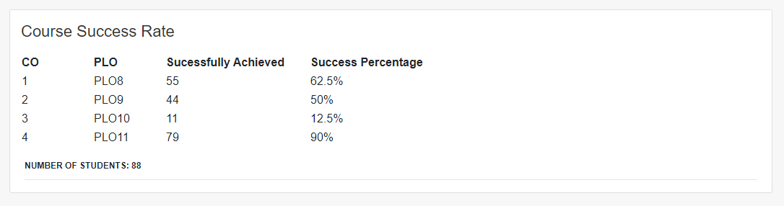

SELECT CONo, PLONo, COUNT(PLOTotal.PLOpercentage) AS Acheived
FROM (
SELECT CO.courseID, CO.CONo, p.PLONo,(PLO / COTotal * 100)
AS PLOpercentage
FROM spm.PLO p,
spm.CO CO,
(
SELECT
en.studentID, c.courseID, c.CONo, c.PLOID, SUM(DISTINCT e.marksObtained) AS
PLO, SUM(DISTINCT a.marksObtained) AS COTotal
FROM spm.enrollment en,
spm.evaluation e,
spm.assessment a,
spm.CO c,
spm.PLO p
WHERE en.enrollmentID = e.enrollmentID
AND e.assessmentID = a.assessmentID
AND a.COID = c.COID
AND c.PLOID = p.PLONo
AND c.courseID = '{}'

GROUP BY studentID, c.courseID, c.CONo, p.PLONo
) perPLO
WHERE CO.CONo = perPLO.CONo
AND CO.courseID = perPLO.courseID
AND p.PLONo = perPLO.PLOID
GROUP BY studentID, CO.courseID, CO.CONo, PLONo
HAVING PLOpercentage >=40
) PLOTotal
GROUP BY courseID, CONo, PLONo;
SELECT CONo, PLONo, COUNT(PLOTotal.PLOpercentage) AS Acheived
FROM (
SELECT CO.courseID, CO.CONo, p.PLONo, (PLO / COTotal * 100) AS PLOpercentage
FROM spm.PLO p,
spm.CO CO,
(
SELECT
en.studentID, c.courseID, c.CONo, c.PLOID, SUM(DISTINCT e.marksObtained) AS PLO, SUM(DISTINCT a.marksObtained) AS COTotal
FROM spm.enrollment en,
spm.evaluation e,
spm.assessment a,
spm.CO c,
spm.PLO p
WHERE en.enrollmentID = e.enrollmentID
AND e.assessmentID = a.assessmentID
AND c.PLOID = p.PLONo
AND a.COID = c.COID
AND c.courseID = '{}'
GROUP BY studentID, c.courseID, c.CONo, p.PLONo
) perPLO
WHERE CO.CONo = perPLO.CONo
AND co.courseID = perPLO.courseID
AND p.PLONo = perPLO.PLOID
GROUP BY studentID, CO.courseID, CO.CONo, PLONo
)PLOTotal
GROUP BY courseID, CONo, PLONo;

Semester-wise Progress:

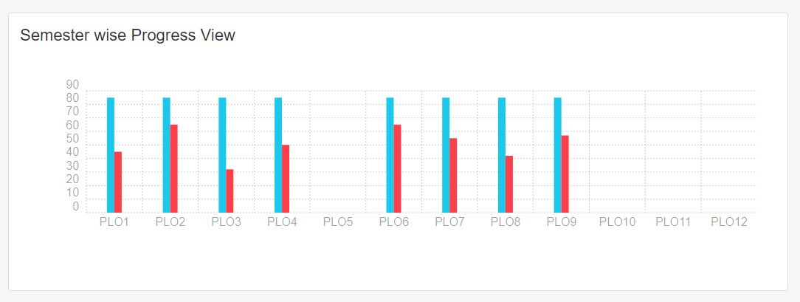

SELECT COUNT(Acheived.ActualPLO)
FROM (
SELECT AVG(PLOTotal.PLOpercentage) AS ActualPLO
FROM (SELECT studentID,(PLO / COTotal * 100) AS PLOpercentage
FROM (SELECT en.studentID, SUM(e.marksObtained) AS PLO, SUM( a.marksObtained) AS COTotal
FROM spm.enrollment en,
spm.evaluation e,
spm.assessment a,
spm.CO c,
spm.PLO p
WHERE en.enrollmentID = e.enrollmentID
AND en.semester = '{}'
AND en.year = '{}'
AND e.assessmentID = a.assessmentID
AND a.COID = c.COID
AND c.PLOID = '{}'
GROUP BY en.studentID
) perPLO
GROUP BY studentID
) PLOTotal
GROUP BY studentID
) Acheived
WHERE Acheived.ActualPLO >= 40;

SELECT COUNT(Acheived.ActualPLO)
FROM (SELECT AVG(PLOTotal.PLOpercentage) AS ActualPLO
FROM (SELECT studentID, (PLO / CoTotal * 100) AS PLOpercentage
FROM (
SELECT en.studentID, SUM(
e.marksObtained) AS PLO, SUM( a.marksObtained) AS COTotal

FROM spm.enrollment en,
spm.evaluation e,
spm.assessment a,
SPM.CO c,
SPM.PLO p
WHERE en.enrollmentID = e.enrollmentID
AND en.semester = '{}'
AND en.year = '{}'
AND e.assessmentID = a.assessmentID
AND a.COID = c.COID
AND c.PLOID = '{}'
GROUP BY en.studentID
) perPLO
GROUP BY studentID
) PLOTotal
GROUP BY studentID
) Acheived;

Program-wise Progress

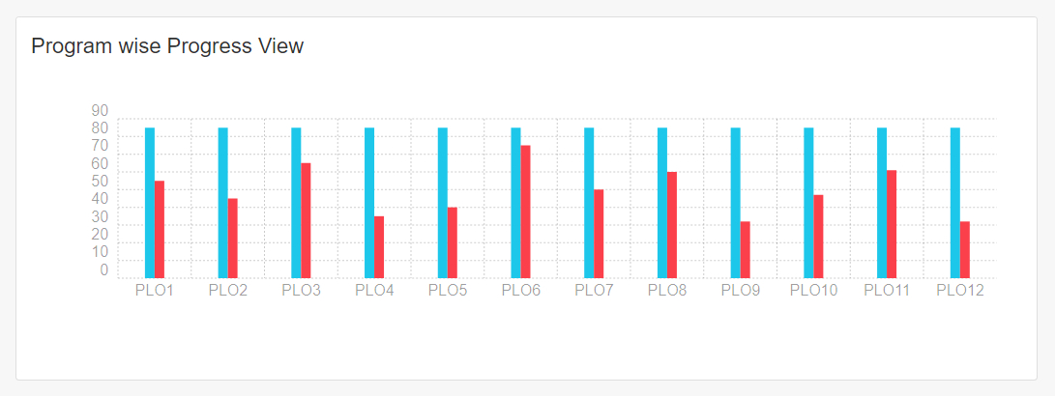

SELECT COUNT(Acheived.ActualPLO)
FROM (
SELECT AVG(PLoTotal.PLOpercentage) AS ActualPLO
FROM (
SELECT studentID, (PLO / TotalComark * 100) AS
PLOpercentage
FROM (
SELECT en.studentID, SUM(DISTINCT
e.marksObtained) AS PLO, SUM(DISTINCT a.marksObtained) AS COTotal
FROM spm.enrollment en,
spm.evaluation e,
spm.assessment a,
spm.CO c,
spm.PLO p,
spm.program pr
WHERE p.programID = pr.programID
AND pr.programID = '{}'
AND en.enrollmentID = e.enrollmentID
AND e.assessmentID = a.assessmentID
AND a.COID = c.COID
AND c.PLOID = '{}'
GROUP BY en.studentID
) perPLO
GROUP BY studentID
) PLOTotal
GROUP BY studentID) Acheived
WHERE Acheived.ActualPlo >= 40;
SELECT COUNT(Acheived.ActualPlo)
FROM (
SELECT AVG(PLOTotal.PLOpercentage) AS ActualPlo
FROM (
SELECT studentID,(PLO / COTotal * 100) AS
PLOpercentage
FROM (
SELECT en.studentID,SUM(DISTINCT
e.marksObtained) AS PLO, SUM(DISTINCT a.marksObtained) AS COTotal
FROM spm.enrollment en,
spm.evaluation e,
spm.assessment a,
spm.CO c,
spm.PLO p,
spm.Program pr
WHERE p.programID = pr.programID
AND pr.programID = '{}'
AND en.enrollmentID = e.enrollmentID
AND e.assessmentID = a.assessmentID
AND a.COID = c.COID
AND c.PLOID = '{}'
GROUP BY en.studentID
) perPLO
GROUP BY studentID
) PLOTotal
GROUP BY studentID
) Acheived;

Student’ Semester-wise Progress

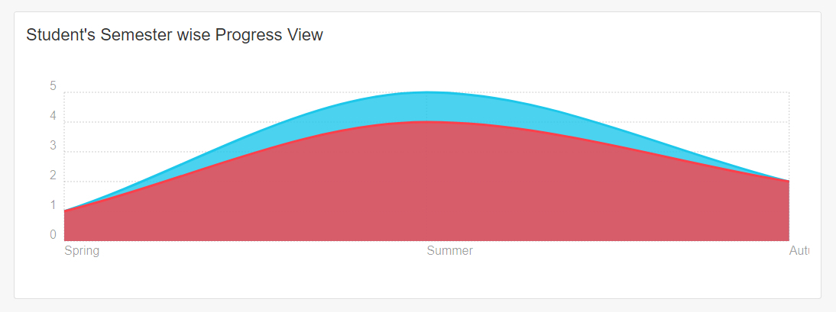

SELECT COUNT(Acheived.ActualPLO) AS isPLOAchieved
FROM(
SELECT AVG(PLOTotal.PLOpercentage) AS ActualPLO
FROM (
SELECT (PLO / COTotal * 100) AS PLOpercentage
FROM (
SELECT SUM(DISTINCT e.marksObtained) AS PLO,
SUM(DISTINCT a.marksObtained) AS COTotal
FROM spm.enrollment en,
spm.evaluation e,
spm.assessment a,
spm.CO c,
spm.PLO p

WHERE en.studentID = {}
AND en.semester = {}
AND en.year = {}
AND en.enrollmentID = e.enrollmentID
AND e.assessmentID = a.assessmentID
AND a.COID = c.COID
AND c.PLOID = 1
GROUP BY en.semester
) perPLO
) PLOTotal
) Acheived
WHERE Acheived.ActualPlo >=40;

SELECT COUNT(Acheived.ActualPlo) AS isPLOAchieved
FROM(
SELECT AVG(PLOTotal.PLOpercentage) AS ActualPlo
FROM (
SELECT (PLO / COTotal * 100) AS PLOpercentage
FROM (
SELECT SUM(DISTINCT e.marksObtained) AS PLO,
SUM(DISTINCT a.marksObtained) AS COTotal
FROM spm.enrollment en,
spm.evaluation e,
spm.assessment a,
spm.CO c,
spm.PLO p
WHERE en.studentID = {}
AND en.semester = {}
AND en.year = {}
AND en.enrollmentID = e.enrollmentID
AND e.assessmentID = a.assessmentID
AND a.COID = c.COID
AND c.PLOID = 1
GROUP BY en.semester
) perPLO
) PLOTotal
) Acheived;

CHAPTER 5
CONCLUSION
● PROBLEM AND SOLUTION
● ADDITIONAL FEATURES & FUTURE DEVELOPMENT
● CONCLUSION & RECOMMENDATIONS

PROBLEM AND SOLUTION
1. For mapping more courses we needed more PLO and CO data which was unavailable to us so we mapped other courses according to CSC303 PLO’s and CO’s
2. We needed more student data from different Department, Course, Program which was also unavailable to us so we created some random data using c++ for different tables of our Database to make our generated reports more Visible and analytical.
3. We also faced limitation of total time frame. Already everyone is going through this pandemic situation, staying home for 24/7 which has a bigger impact in our mental health plus Some of us also had multiple projects in different courses so it was quite tough for us completing the whole project in a mean time.While everyone is living in different places it was also a challenging task for us to have a good team management. we did much we could.
ADDITIONAL FEATURES AND FUTURE DEVELOPMENT
1. In addition we are planning to add some other features too such as improving the front end, making it more user friendly.
2. We are also planning to add an additional python script to automate the student evaluation and grading task. The script will automatically input data from section wise google spreadsheet file to our Logical Database.

CONCLUSION AND RECOMMENDATIONS

We believe that with a little more improvement we can deploy our system to our University server for multiple use. Though we already tried to put our system to a cloud platform but because shortage of time we couldn’t complete it. This software is serviceable to students who want to improve themselves as better and more competent scholars, for faculties to keep better track of their students and improve their teaching methods accordingly, and for the members of the institution to better regulate their resources.

Thank You

